Kaylin Archuleta, Serite Ross, Linh Tran

Proposal for MusicSpace

Table of Contents

Executive Summary 2

Gap in the Market 2

Meeting the Market’s Needs 2

Implementation 3

Management 3

Development 3

Marketing and Distribution 3

Monetization 3

The Problem and Our Solution 3

Industry Need for Our Technology 4

Market Analysis / Primary Market / Secondary Market 4

Marketing Strategies 4

Overview 4

Primary Customer analysis and entry strategy 5

Core competency 5

Sales Strategy 5

Competition 6

Development Strategy 6

Barriers 7

Critical Risks 7

Interviews 8

# Executive Summary

Today, we have many options available for streaming music. Regardless of the website, all of them allow users to stream music and create playlists. The problem is that some music may only be available on certain platforms. One artist might only post their content to YouTube, others only to Soundcloud, and so on. Our goal is to provide a unified interface where our clients can connect their favorite music platforms and listen to their music from one website and provide the functionality that allows them to create cross-platform playlists.

Our target client base is expansive, since MusicSpace is meant to be for everyone who wants to consolidate all their playlists into a single platform. We also plan to implement a feature that will allow sharing of playlists within the website and the ability to follow others to get notified of their playlists. There is no limit to the amount of playlists a user can create, and user may add as many songs from as many platforms as are made available on our website. Currently, our competitors would be Openwhyd, an open source, volunteer-maintained platform.

MusicSpace aims to be an affordable, simplistic solution to unifying all your playlists. It will be developed using open source technology and will have both a free and subscription based plan.

# Gap in the Market

In the current market, options for creating playlists composed of music from multiple platforms are slim. The only ones that are still functional today are small platforms called Openwhyd and Great DJ, both of which are open-source. Great DJ is limited to creating playlists only between YouTube and Soundcloud, which is a big limitation. Openwhyd is able to import from a larger number of websites, but has trouble handling requests for certain videos. Across both websites, there seems to be issues with functionality that either make them slow to load content or they have features that don’t work. Customers of other products would be eager to convert to our service due to its speed and compatibility with connected platforms.

# Meeting the Market’s Needs

MusicSpace will meet the market’s needs by providing a space for users to make and share playlists without having to pay for multiple subscription services or use multiple sites. The site will have more personalization than competitors and this feature that competitors lack will drive users to use the site. MusicSpace will also be designed to be as user friendly as possible to have an accessible and easy to read interface.

# Implementation

## Management

MusicSpace will be managed by its developers.

## Development

MusicSpace will be developed using the the following technologies:

* Frontend (UI):
  + React – Javascript library for creating graphical interfaces
  + Relay – Javascript library for handling queries sent through React
* Backend (Web Server / Database):
  + Node.js – JS runtime environment
  + Express – Web framework for Node.js
  + GraphQL – query language
  + MariaDB – database for storing user data

## Marketing and Distribution

We will offer a trial period of one to three months for each new user, then allow them to subscribe later. Point system for creators which will encourage them to use our application.

## Monetization

Monetization of MusicSpace will be accomplished through a subscription model. Users can choose to subscribe monthly or yearly.

# The Problem and Our Solution

The problem with the current solutions on the market is that there are too many music applications with their own exclusive selections of music and artists, which forced users to pay for multiple music streaming services at the same time. It is time-consuming and inconvenient to switch between streaming services.

MusicSpace aims to provide an accessible, affordable, all-in-one application for users of all ages for their music needs.

# Industry Need for Our Technology

We will serve as a hub for your music needs. From searching and streaming curated playlists, recognizing songs from lyrics to personalizing your own favorite selections of songs, etc. We will provide a single platform to replace your need for multiple music applications for entertainment with simpler, more customizable interfaces with less cost, which allow you to discover new music within a few clicks.

# Market Analysis / Primary Market / Secondary Market

The main competitors for MusicSpace would be Spotify, SoundCloud, and Apple Music. These are all well-established music streaming services in the market. Spotify has been well known for their massive music libraries; SoundCloud is known for the ease of uploading music on their platform, and Apple Music is integrated into Apple’s ecosystem with its huge customer base. Our goal is to make it more convenient and money-saving for our customers to enjoy all kinds of music without the hassles of having multiple platforms.

The primary market will focus on younger customers (15-30 years old) like college students as their entertainment and music needs are more apparent. The secondary market will focus on professional adults in their 30s and up.

# Marketing Strategies

## Overview

MusicSpace wants to capture the music streaming service market. To achieve this goal, we have to provide the users with a high-quality, easy-to-use application with many unique, desired features that will set us apart from other applications while keeping the price affordable. We intend to keep the cost of development low to maximize profits and allow room for further development of the application for new features on demand. We will also continue updating and improving the features that are integrated initially.

## Primary Customer analysis and entry strategy

To enter the market, we aim at younger users initially as they have the most entertainment needs and are more willing to try out new products by offering a quality, customizable, aesthetically pleasing product for free to encourage them to try out our application. After this trial period, they will be offered the option to pay a subscription fee to keep using the product. As the application becomes more well known, more people will want to try out our application and can easily do so through our free trial.

## Core competency

The core competency of MusicSpace is being able to provide an all-in-one music streaming platform at an affordable price. MusicSpace will allow users more freedom to customize their own music playlists with more features such as built-in song recognition, sleep timer or playlist collaboration.

Expansion Strategy: Our team will constantly update and add new features to MusicSpace to make it standout more than our competitors, which will give us a stronger stand in the market. We will ask for customer feedback to further satisfy our existing customer base and add features they request to make our product more appealing to new customers. We would like to become the go-to application for everybody's music needs at a lower price.

## Sales Strategy

**Pricing**

First time users will get a free trial for a limited time. After the trial ends, they will subscribe either monthly or annually. Annual subscription will be available as a discounted price relative to the monthly price to attract customers to a longer commitment. MusicSpace’s subscription fee will be lower than our competitors in the market while providing customers with a platform that is designed based on their preferences.

We will also be offering student discounts as they will be our main customer base.

**Positioning**

We plan to design MusicSpace to be a simple, efficient, fun, social, and customizable platform for any user who chooses MusicSpace for their entertainment needs. We will also address as much customer demand as possible.

**Promotion**

We will use multiple promotional strategies like internet marketing and targeted advertising. We also plan to use a referral program like a reward system for users who refer the application to their friends to expand our customer base.

**Place**

MusicSpace is a startup and can be developed and run from home.

# Competition

**Spotify**

A digital music streaming service that allows access to thousands of songs, podcasts, and videos from artists all over the world.

**SoundCloud**

An online audio distribution platform and music sharing website.

**Apple Music**

A music and video streaming service developed by Apple.

**Openwhyd**

An online streaming service that allows its users to compile cross-platform playlists.

# Development Strategy

MusicSpace will be developed in stages to make sure that everything is working properly before adding new features. Since we will be using sources across the web, more sources will be added at each stage and ensure compatibility, along with new interesting features for a greater user’s experience.

Seed stage: In this stage we will create a viable prototype to get our application going.

Startup stage: We will implement the existing prototype as the backbone of the product.

Development stage and launch: all sources and features will be developed in detail and tested. Eventually, users will be offered beta version for free to test out and their feedback will be recorded for the team to complete the application. Once we determine that the application is of high quality and functioning properly, it will be released for public use.

# Barriers

We will face many barriers in this market including but not limited to:

* Technology and software development
* Lack of creators due to initial small userbase
* Hesitation to transition from users’ go-to services
* Collaborations with other competitors in the market for their exclusive content
* Frequent updates
* Algorithm precisions with machine learning

# Critical Risks

A major risk of MusicSpace is that our competitors have monopoly over the market, therefore, customers will not want to switch to using a smaller, newer application. As a small group of developers, it will take time for us to develop an application full of features desired by the users.

However, we will create a quality application that ensures the best user's experience. As we develop the application, we will deliver the promised features. To attract customers, we will integrate more unique features like sleep timer and conduct quality control often to ensure a bug-free platform, while providing fast customer support for the users.

# Interviews

The following questions were asked in an online survey:

**Would you be interested in a new website/app for making personalized music playlists, using sources from different sites across the internet?** 31 responses

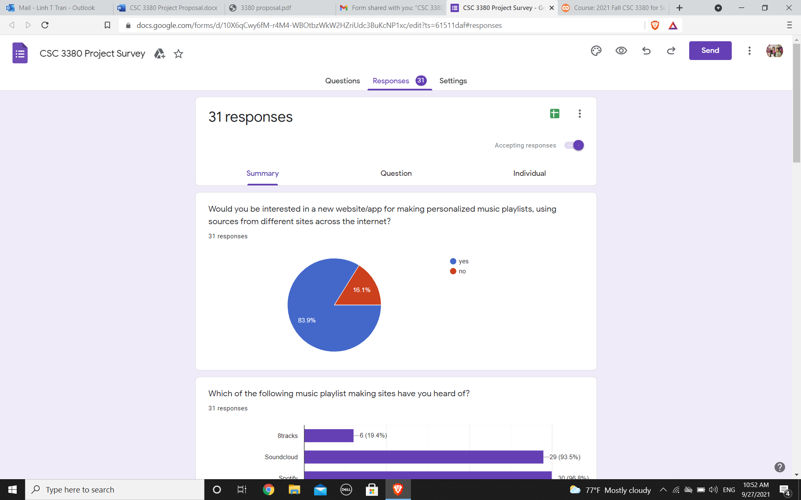

**Which of the following music playlist making sites have you heard of?** 31 responses

8tracks(6)

SoundCloud(29)

Spotify(30)

**Which of the previously listed sites/apps do you use for music playlists the most?** 31 responses

SoundCloud(10)

Spotify(22)

Youtube(3)

Apple Music(3)

Other(2)

**What do you like about the playlist making website/apps you have used?** 31 responses

Recommendations for songs, similar to the ones I already like

Selection of music and genres(4)

Update latest song immediately

Ability to reorganize songs, add cover images, find recommendations

It’s very convenient and easy to find the music you want and to save them in such a way to where I never have to listen to things I don’t like again

the personalization of it

It’s easy to access and use (3)

good curation of music, ease of use, wide range of music, no ads (at least with my plan)

It recommends new music every Friday

Easy access to music by any creator on the platform, free to use, playing while the phone is in sleep mode

It has a good interface.

It saves me time.

Easy to use, have suggestions, I really like Spotify's collaboration feature with playlists and I like how on YouTube you can add covers to playlists.

Easy to search up songs

Optimizes the songs I like to listen to

**What do you dislike about the playlist making websites/apps you have used?** 31 responses

Ads (6)

They may have some limitation that does not allow me to download some playlist if it marks as official copy right.

i don't like the amount of skips you get, i would like more, and sometimes the '30 min ad free' sessions aren't actually that long or don't even work

Sometimes the layout is not pleasing to the eye

It randomizes everything to make me get premium.

Hard to work

only certain songs are available on each of the platform

That I have to pay for it without adds

when music is removed from a playlist

When I was in down mood, the apps just accident played happy song or hiphop songs that made me feel annoy

Limit to songs D: Also on spotify I kinda hate that it shows you the date you added a song because if I add songs on another day it doesn't match and it bugs me >:(

Nothing (6)

It doesn’t have all the music I look for

Honestly other people make them and some of the songs are horrible.

Sometimes songs I want are blocked

Spotify doesn't always have playlists and sometimes, songs are unplayable due to copyright/ownership issues. YouTube's playlists are kind of finnicky sometimes (ex. their shuffle doesn't really shuffle)

App bugs

Limited songs

**What features would you be interested in?** 31 responses

Free music (3)

Download songs, create my own playlist

a different kind of shuffle. like shuffle that takes cues from your environment. i saw it once but forgot how it worked.

i wish that, no matter what, you can start on any song that you want. sometimes i wanna listen to a specific song and don't want to wait for it

A more clear and good looking design

Maybe skip as many songs as possible

Free song skips and the option to play songs in order without paying.

Sharing and curatorial functions

songs listed base on playing frequencies. no ads

Almost having a Shazam in the app. So if I don’t know a song it can detect it and store it for me to listen to later on

information about my listening happens (eg, what I listen to the most ect..)

Update the currently hit songs

Maybe like suggestions that aren't like super popular songs, but songs with less listeners so you can discover new music?

To be honest with you, I don’t really think there are many features that can be added that are necessary and not just something niche that few would use. Spotify and Apple Music cover a very large portion of the marker and do most of what you can do.

maybe something that can generate accurate playlists of music i might be into

High quality low storage

More personalization

ability to add in a song from youtube

Sleep timer

Broader incentives for musicians to use the platform

A better algorithm that fits me

Being able to add songs not already on the app

Collaboration features, being able to make playlists private/publics, adding friends, dark mode, customizing basic interface features

N/a (3)